1. Create Angular application which creates two custom directive as CompSuccess and CompFailure. In case of success when move mouse cursor over data its color become green and in case of failure text color become red. When we remove mouse its color become black.

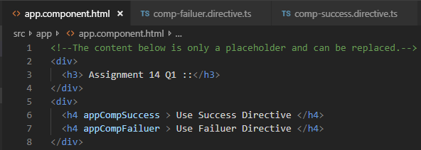

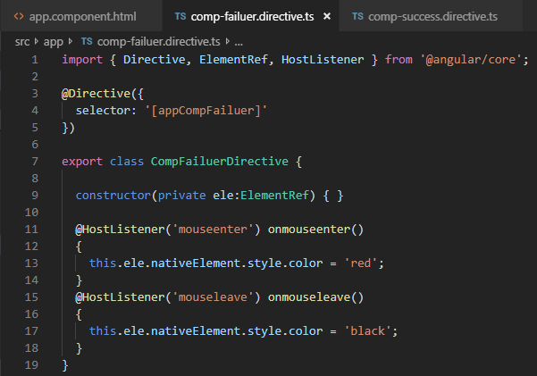

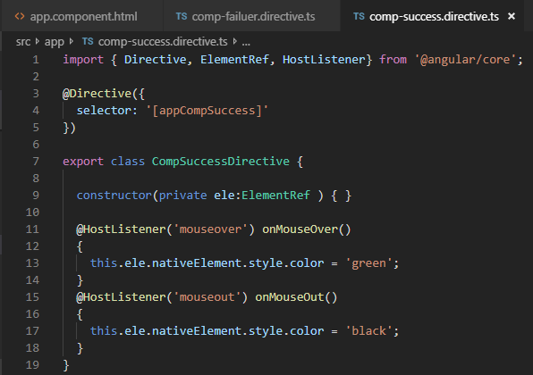

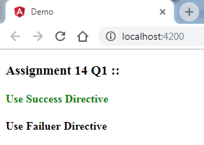

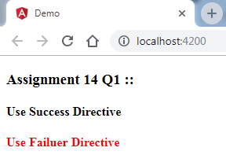

1. Create Angular application which creates one custom directive as CustomStyle. In this case set background color of text as yellow and text type should be bold. No need to handle mouse listener.

